Match the book to the name of the writer.

- 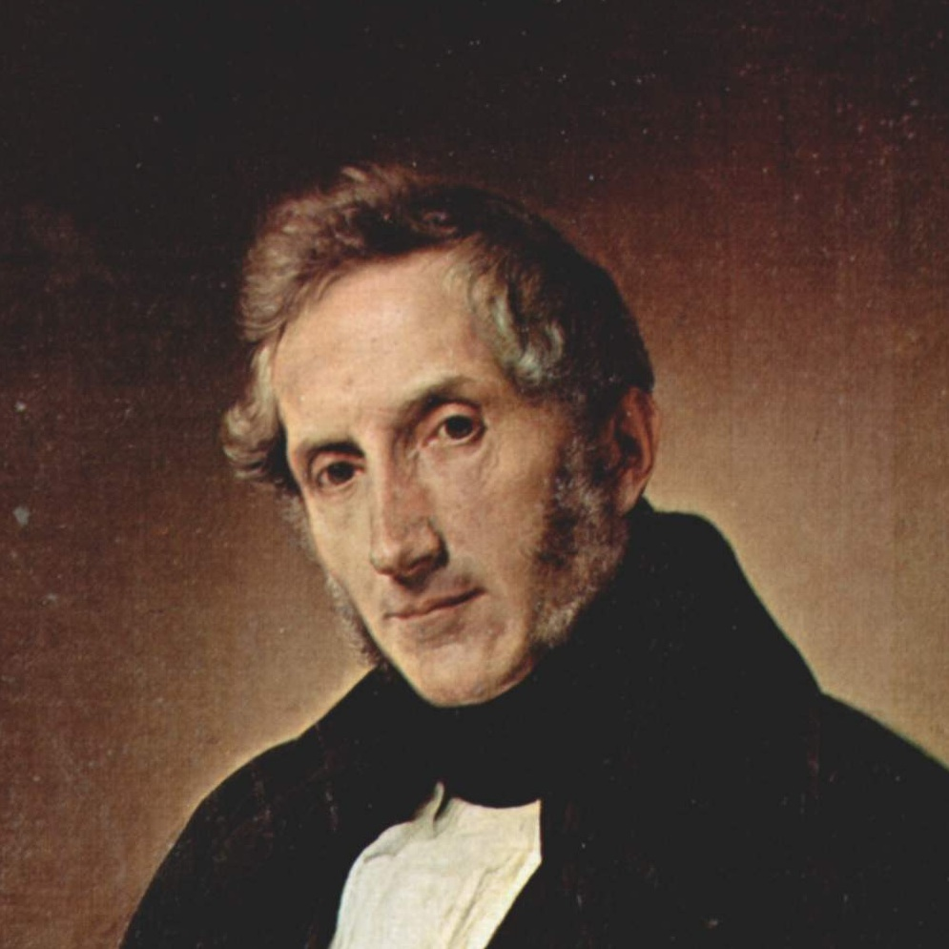 “The Betrothed”
- Ugo Foscolo
- Alessandro Manzoni
- Francesco Petrarca
- Giacomo leopardi
Answer: b
- 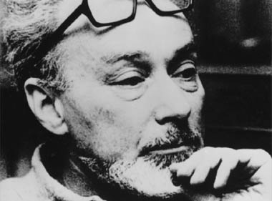 “ If this is a man”
- Enzo Biagi
- Gabriele D’Annunzio
- Italo Calvino
- Primo Levi
Answer: d
- 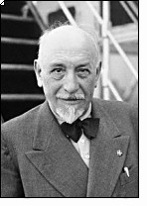”Was Mattia Pascal”
- Luigi Pirandello
- Alessandro Manzoni
- Eugenio Montale
- Giovanni Verga
Answer: a
- 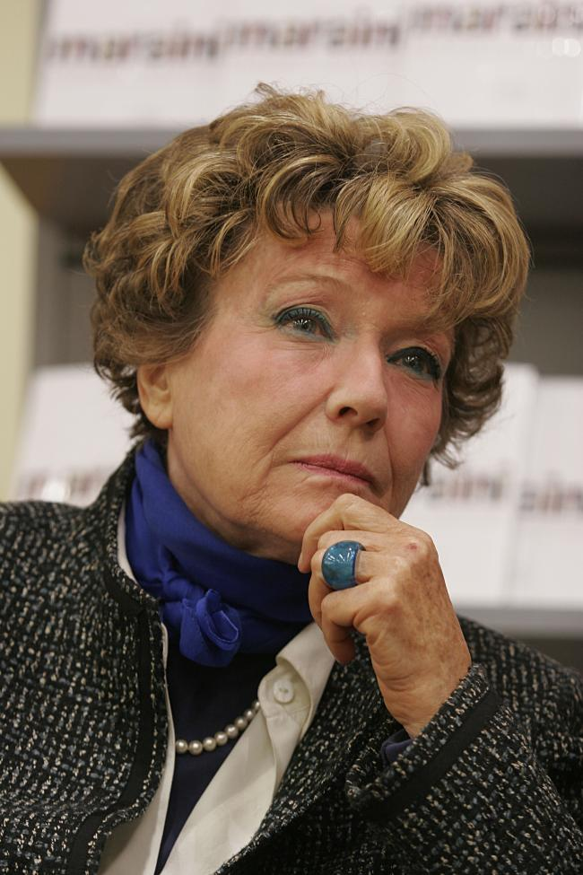 “Dove”
- Lalla Romano
- Elsa Morante
- Dacia Maraini
- Margaret Mazzantini
Answer: c
- 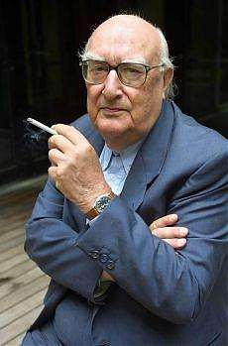 Inspector Montalbano “The Shape of Water”
- Erri De Luca
- Paolo Di Paolo
- Andrea Camilleri
- Italo Calvino
Answer: c

